|  |  |  |  |
| --- | --- | --- | --- |
| An Introduction to Programming Using Visual Basic 2017 | |  | Hardware and Software   * Hardware * physical components of a computer * Software * set of instructions that tell computer what to do   Chapter 1 -VB 2017 by Schneider 2 |
|  |  |
| Chapter 1, 2  An Introduction to Computers and Problem Solving | |
| Programming Languages   * Low level (machine language) * Hard for humans to understand (0s and 1s) * High level (more English-like) * More easily understood by humans * Instructions like If … Then, Do While …, arithmetic statements   Chapter 1 -VB 2017 by Schneider 3 | |  | What is Programming?   * Problem solving * break problem down into steps * Algorithm * set of step by step instructions * Program * set of step by step instructions that tell computer what to do * written in a programming language * must be written so computer understands them * must follow set of syntax rules   Visual Basic 2017 4 |
| Basic Programming Tasks   * Declarations * commands to tell computer what data is used in a program * Input (raw data) * data entered into computer from user * Processing(calculations, formatting, sorting …) * work done by the program * Output (information) * results or answers   Visual Basic 2017 5 | |  | Following Directions  Computer   * does only what you tell it to do * follows directions exactly * not bored by repetition * almost never makes a mistake   Visual Basic 2017 6 |

|  |  |  |
| --- | --- | --- |
| Programmer/User   * Analyst * person(s) that develops specifications, designs program * Programmer * person(s) that creates algorithm, writes code, tests program * User * person(s) that uses finished program * You will be both programmer and user   Visual Basic 2017 7 |  | Visual Basic Programming   * Access Visual Basic * Create a Visual Basic project * Save a Visual Basic project * Develop a Visual Basic project * Run a Visual Basic program * Review * Debug a Program (correct errors) Visual Basic 2017 8 |



Visual Basic 2017

9

Create a New Project

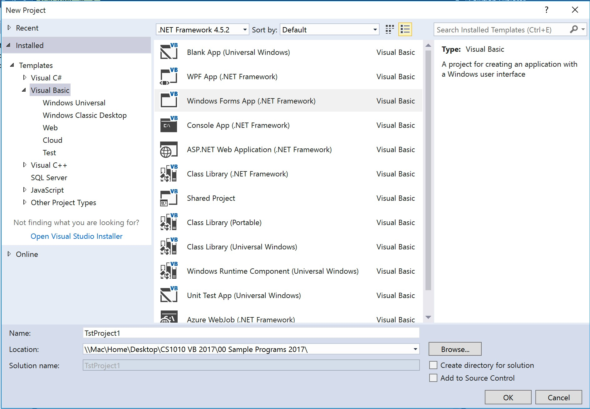

Visual Basic 2017

10

Sample VB Program

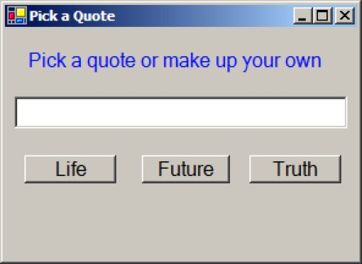

|  |  |  |
| --- | --- | --- |
| Running a Visual Basic Program  *1.*  2.  3.  Visual Basic 2017 11 |  | Saving a Visual Basic Project  1.  2.  3.  Visual Basic 2017 12 |

|  |  |  |  |  |
| --- | --- | --- | --- | --- |
| Opening a Visual Basic Project  1.  2.  3.  Visual Basic 2017 13 |  | | Turning in a Visual Basic Project Electronically  1.  2.  3.  4.  Visual Basic 2017 14 | |
| |  |  | | --- | --- | | Developing a Visual Basic Project  1. Design User Interface   * Add controls * Set Properties  1. Determine events each control should recognize 2. Write Event Procedure Code   Visual Basic 2017 | 15 | | | | Visual Basic 2017  16  Set Properties  Categorized view Alphabetical view | |
| Set Properties    Visual Basic 2017 17 |  | | Set Name Property   * Name used to refer to a control in code * Name must begin with a letter * Must be less than 215 characters long * May include numbers and the underscore * Use appropriate 3 character naming prefix   Visual Basic 2017 18 | |

|  |  |  |
| --- | --- | --- |
| Visual Basic 2017  19  Control Name Prefixes | |  | | --- | | Running a Visual Basic Program   * What happens when you run a Visual Basic program? * What is an event? * What is an event procedure? * How do you create an event procedure?   Visual Basic 2017 20 | |
| Visual Basic 2017  21  Code Editor  Code Editor tab  Form Designer tab  Event  Control | |  | | --- | | Changing Properties of Controls in Code  ***controlName.property = setting***  ***Examples:***  txtQuote.Text = "I like life, it's something to do." txtQuote.ForeColor = Color.DarkRed txtQuote.TextAlign = HorizontalAlignment.Center  Visual Basic 2017 22 | |
| Visual Basic 2017  23  IntelliSense  Automatically pops up to give the programmer help. | |  | | --- | | Review: Form   * Contains one or more controls * Text property default is **Form1** * Enter a more meaningful name * Where does form's text property appear? * DO NOT change (Name) property Visual Basic 2017 24 | |

|  |  |  |  |  |
| --- | --- | --- | --- | --- |
| Review: Button   * Name property prefix ____________ * Where does Text property appear? * What is most common event? * Purpose   Visual Basic 2017 25 |  | | Review: Label   * Name property prefix ______________ * What is most used property? * Purpose? * Usually placed to left of ____________ Visual Basic 2017 26 | |
| Review: Text Box   * Name property prefix ___________ * What is most used property? * Purpose? * Common events?   Visual Basic 2017 27 |  | | Program Errors (Bugs)   1. Syntax (Compile-time) Errors 2. Run-time Errors 3. Logic Errors   Debugging -process of removing errors  (bugs) from your code  Visual Basic 2017 28 | |
| |  |  | | --- | --- | | 1. Syntax Errors   * Spelling, punctuation, grammar errors detected by: * Code editor as you type * Compiler when you compile (build) * What are syntax (compiler) errors below?   txtHello.Text = Hello World tstHello.Text = "Hello World" txtHello,Text = "Hello World"  Visual Basic 2017 | 29 | | | | Visual Basic 2017  30  Syntax Errors Detected by  Compiler | |

|  |  |  |  |
| --- | --- | --- | --- |
| Visual Basic 2017  31  Syntax Errors Detected by  Compiler | |  | | --- | | 2. Run-time Errors   * Caused by running program containing statement that computer cannot execute * E.g., Attempting impossible arithmetic operations like divide by zero, calculations with nonnumeric data * Stops execution (running) of program   Visual Basic 2017 32 | | |
| 3. Logic Errors   * Program compiles and runs without errors * But produces incorrect results   Visual Basic 2017 33 |  | Event Procedures  **Private Sub objectName_event(...)**  **Handles objectName.event *statements to handle event***  **End Sub**  **Private Sub btnTruth_Click(...)**  **Handles btnTruth.Click**  **txtQuote.Text = "Tell the truth and run." txtQuote.ForeColor = Color.Black**  **End Sub**  Visual Basic 2017 34 |
| Changing Properties in Code   * Program statement to set a property:   ***controlName.property = setting***   * Examples:   **txtQuote.ForeColor = Color.Black txtQuote.Text = "Hey now!" btnFuture.BackColor = Color.Blue**   * These are assignment statements Visual Basic 2017 35 |  | Sample Code  **Private Sub btnLife_Click(…)Handles btnLife.Click txtQuote.Text = "I like life, it's something to do."**  **txtQuote.ForeColor = Color.Black**  **End Sub**  …  **Private Sub btnTruth_Click(…)Handles btnTruth.Click txtQuote.Text = "Tell the truth and run."**  **txtQuote.ForeColor = Color.Black**  **End Sub**  **Private Sub txtQuote_TextChanged(…)Handles txtQuote.TextChanged txtQuote.ForeColor = Color.Red**  **End Sub**  Visual Basic 2017 36 |

|  |
| --- |
| Review: Visual Basic Project   * Creating your project * Name * Location * Locating your project * Turning in your project   Visual Basic 2017 37 |